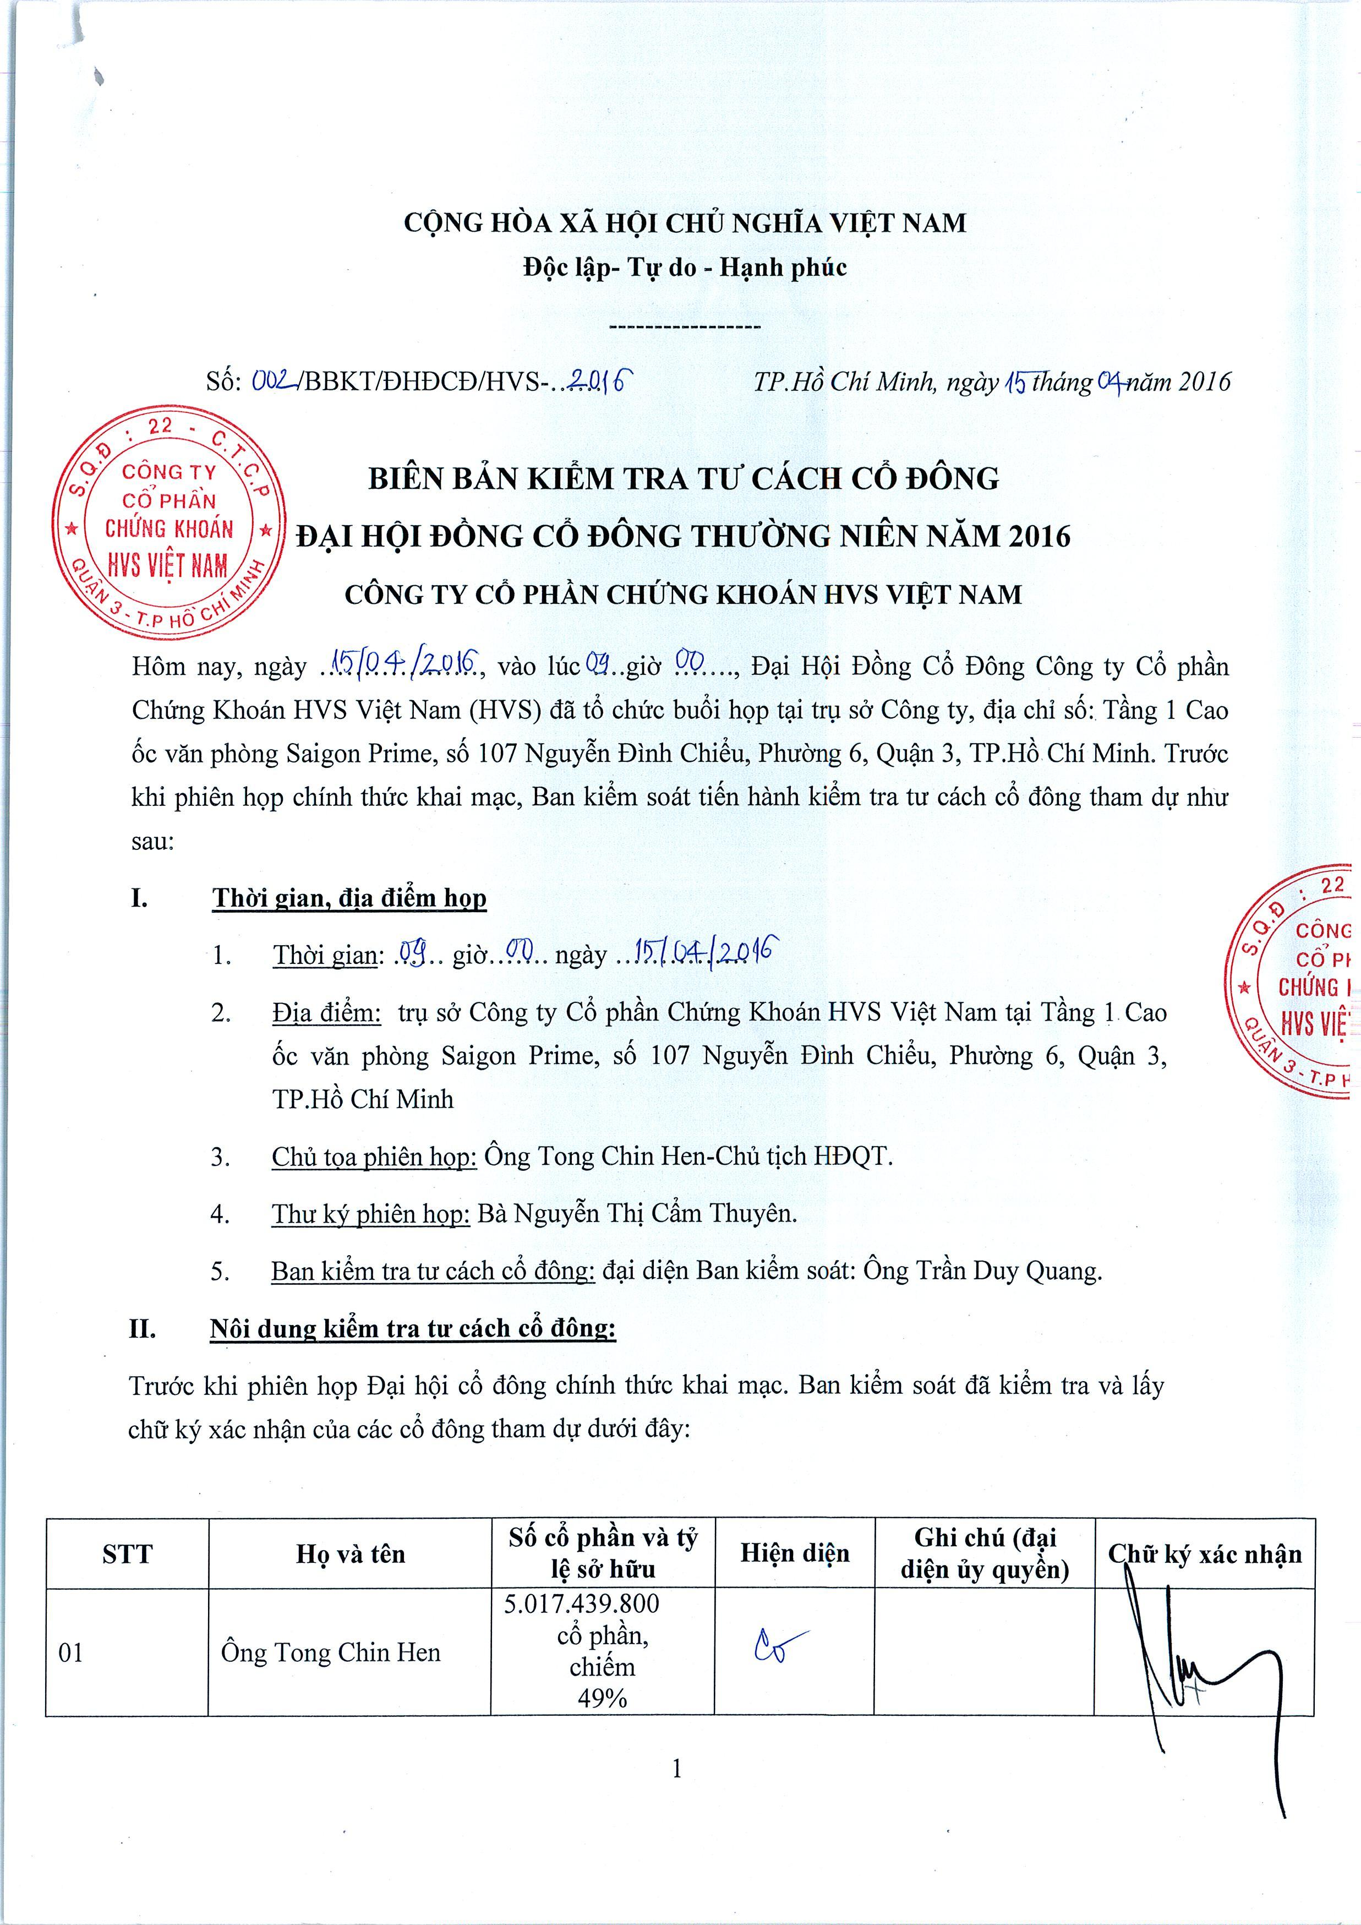

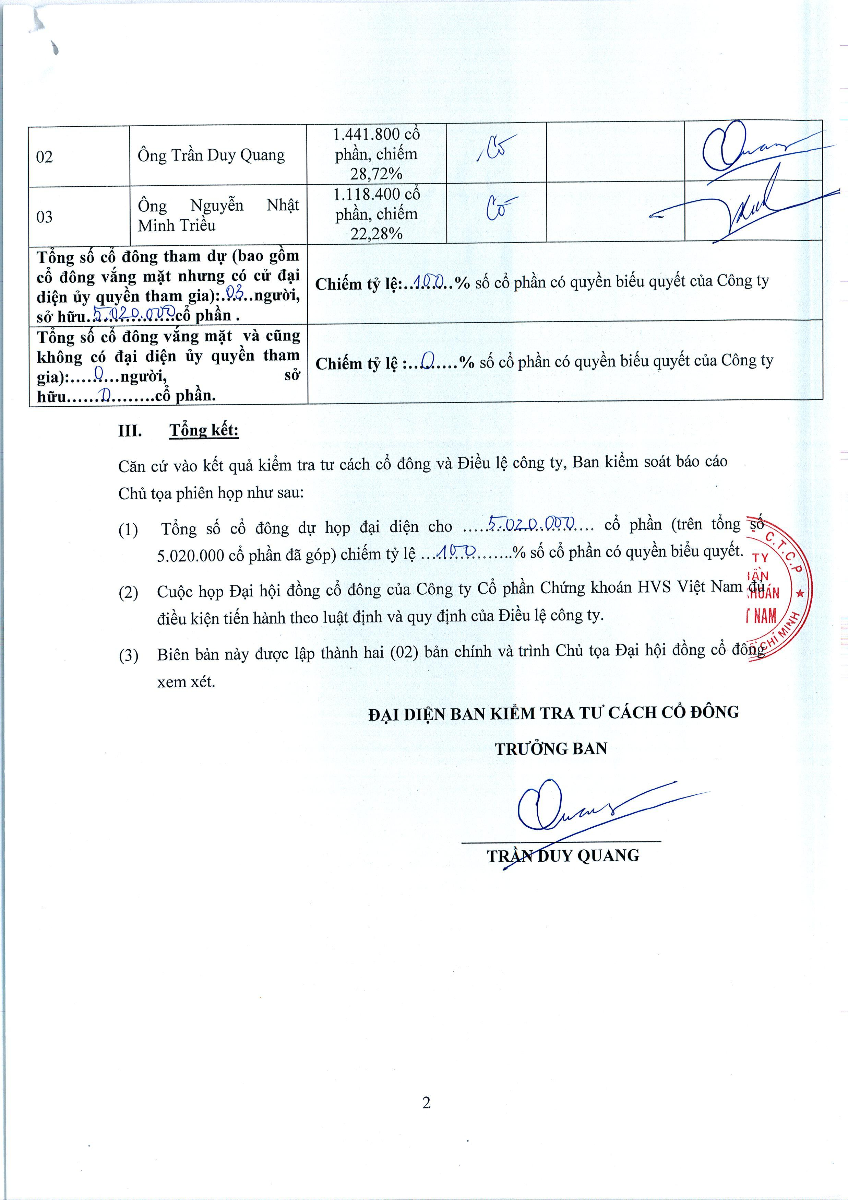
Thank you for trying 1-2-3PDF to Word.
Please note that 1-2-3PDF to Word trial version converts only limited pages of your document.
To convert your complete document, you need to purchase 1-2-3PDF to Word.
To order, please visit: http://www.123pdfconverter.com/multi-file-converter.asp

